Chest X-Ray Guide:

Mnemonic: PIPER N ABCDE

Patient Information | 1) Name and Demographics  2) Clinical History  3) Previous Imaging
Inspiration | Count the anterior ribs  - Normally 6 anterior ribs above diaphragm, with 7th rib penetrating though diaphragm  - >= 7 ribs above indicates hyperinflation
Penetration | Should just be able to outline thoracic vertebrae through cardiac shadow in a sufficiently penetrated X-Ray
Exposed Area | All 6 lung zones visible:  1) Upper: apices to 2nd costal cartilage  2) Middle: between 2nd and 4th costal cartilage  3) Lower: between 4th and 6th costal cartilage
Rotation | Medial ends of clavicles should be equidistant from midline spinous processes.
NG Tube Location | Tip should be visible in gas bubble of stomach if well-placed  * Also comment on presence of ETT
Airway | 1) Tracheal Deviation  a) Deviated Toward (Collapse, fibrosis, tumors)  b) Deviated Away (Effusion, pneumothorax, tumors)  2) Tracheal Narrowing- uncommon; indicates malignancy
Breathing | 1) 6 Lung Zones (Normal, white, dark, too many lines)  a) White:  - Collapse (uniform opacity)  - Effusion (uniform opacity)  - Consolidation (localized patchy opacities w air bronchogram)  - Pneumonectomy  b) Dark:  - COPD (hyperinflation, flat diaphragm, stretched heart)  - Pneumothorax (radiolucent shrunken lung margins)  c) Too many lines  - Fibrotic lung (reticular nodular shadowing)  * Causes- idiopathic, allergic extrinsic alveolitis, drugs (methotrexate), connective tissue dx  - Pulmonary edema (bilat. symmetrical opacity, cardiomegaly, pleural effusion)  2) Hilar- Pulmonary vessels and lymph nodes (L higher than R)  * Bilateral hilar lymphadenopathy ddx: Sarcoidosis, Tuberculosis, Lymphoma
Circulation | 1) Note heart silhouette (aortic knuckle and L/R heart borders)  - Swelling at borders indicate aortic/ventricular aneurysm  - Loss of borders indicate adjacent lung lobe pathology  2) Heart size- Heart/Thorax sixe > 0.5 indicates cardiomegaly (PA X-Ray optimal)  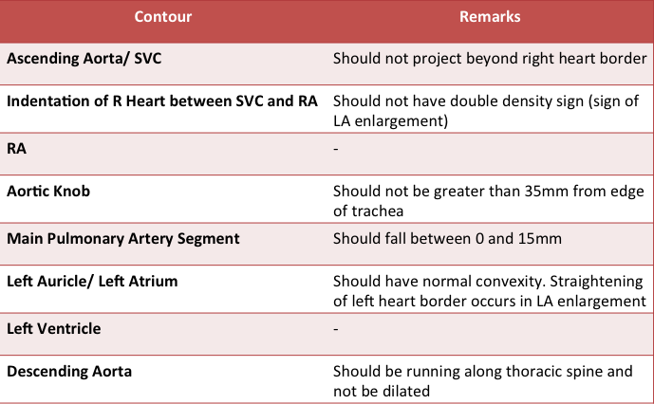
Diaphragm | 1) R higher than L  2) Look for tenting (phrenic nerve palsy, fibrosis)  3) White plaques (asbestosis)  4) Costophrenic angle blunting (small pleural effusions)  5) Gas bubbles/ free air beneath diaphragm
Everything Else | 1) Soft tissues (swelling, surgical emphysema, breast shadows)  2) Bones (#/ dislocation- clavicles, scapula, humerus, ribs)  3) Medical implants (pacemakers, central lines)

