A guide to doing electives at CMC (Last updated: 22/08/2017)

So you have decided to do an elective posting at CMC? Great! This guide is an accumulation of what we have figured out by trial and error; we hope that it will help to smooth out your admin, but please do not rely entirely on this as things may change. Do try to travel in groups instead of individually.

A. Before you leave

1. Apply to DO

As with every other elective, go to the electives portal and make the request to do an elective with CMC. This is a Self-Arranged Overseas Elective. This should not be an issue given the numbers that come to CMC every year.

Remember to request for the “letter of good standing” which you will need to apply to CMC.

2. Arrange with CMC

Email princi@cmcvellore.ac.in with your elective requests, preferably at least 4 months in advance. CMC is quite happy to take in elective students and you should be able to have your elective approved. CMC usually replies within at most a few weeks.

You will need to submit via email, for each person - (attached documents)
- A clinical posting application form (“Clinical posting schedule”) in which you choose which departments you will like to be posted to. Except for your first week, this can be changed when you arrive
- A form of your particulars (“MCI application”) which is submitted to medical council of india for permission for your elective.
- The Letter of Good Standing from NUS DO
- Passport photocopy - please use the same passport that you will travel withyou’re your passport will have <6 months validity when you travel, renew it first
- Passport photo

You will need to pay Rs 8000 per person (SGD $170) for the application fee and for the MCI application fee. This should be remitted to CMC account (attachment: “CMC Bank Details”), which can be done online for most banks. DBS/POSB has a special “India Remit” which you can use without transfer fees - follow the screenshots below.

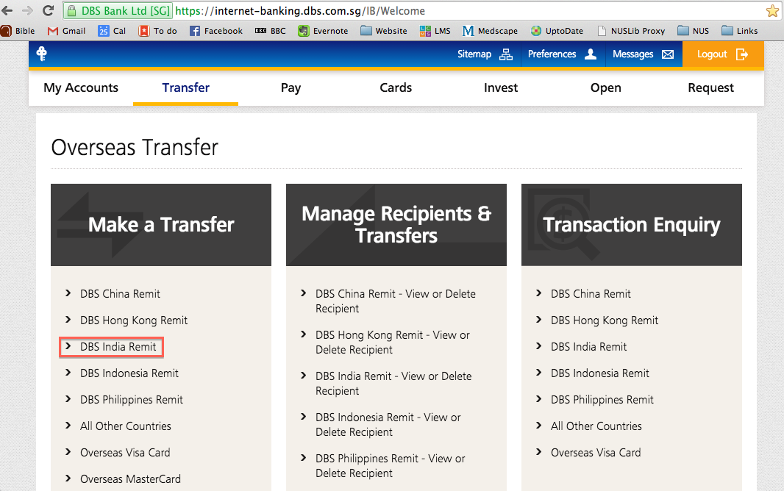

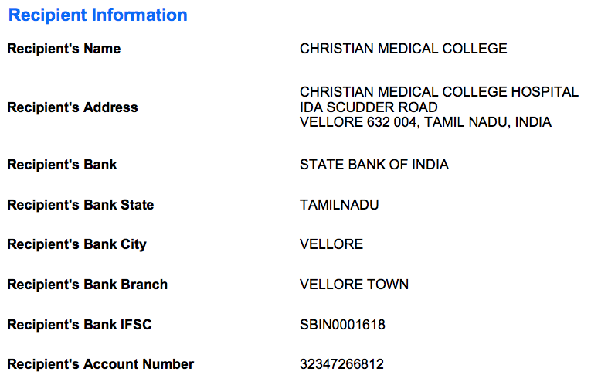

3. Book flights

You should generally fly in to Chennai airport, which is then a 2h taxi ride away from Vellore (where CMC is). A number of airlines fly from Singapore to Chennai, including SIA/silkair and Indigo. You are probably familiar with online flight booking and we will not elaborate further.

Unless you intend to stay over in Chennai, do arrive on a daytime flight. It is less safe to arrive at night and travel from Chennai to CMC while it is dark.

4. Book accommodation

The recommended accommodation is CHTC guesthouse. This is CMC’s own guesthouse, technically not meant for students, but they are happy to have us stay. It is the only available CMC accommodation with much-needed air-conditioning.

Alternatives are
- Modale international students’ hostel: much cheaper (SGD 5), but without air-con. Most international students from other countries stay here too so this is a great place to network and make new friends. Also, Modale hostel has a kitchen, washing machine, iron board and a common lounge unlike CHTC.
- Outside hotels: will be more expensive, and often less convenient

Cost is Rs 900 (SGD 20) per night per room (each room fits two). Payment is by cash when you check-out.

To book, email Mr Samuel, sam@cmcvellore.ac.in, with your details. Please confirm your posting and trip details before booking accommodation; avoid making changes. If you are unsure, you can write in with an enquiry without making a firm booking. Payment for accommodation is made only when you are in India.

5. Arrange taxi between Chennai airport and CMC (CHTC)

CMC’s transport department is happy to arrange taxis from Chennai airport to CMC for us. Email transport@cmcvellore.ac.in and inform them of (a) your flight numbers, arrival date and time, departure date and time, (b) the number of people. The trip will take around 2.5-3 hours. Send a reminder to the transport department a few days in advance regarding your booking to ensure that your taxi comes.

Cost is
- From Chennai airport to CMC: Rs 4000 + a small tip (about Rs 200 will do)
- From CMC to Chennai airport: Rs 4000 + a small tip (about Rs 200 will do)
- Note: Prices have been increasing year after year. Do exercise your own discretion. The above prices are for 1 normal-sized car for 4 people. The car will fit 4 people exactly with minimal leg room, so it is recommended to just fit 3 people if possible, especially because the boot isn’t big and extra luggage space is needed.

6. Apply for visa

This can be a bit of a pain; you do need to set aside a weekday morning and go down in person: plan this in advance around your clinical postings. Good news is that the visa office is actually quite efficient (it has been outsourced); the application process is tedious but the approval does not take long. Nevertheless, it is best not to do this at the last minute - especially if you are not holding a singapore passport. From 2015, it is possible to apply for visa on arrival at Chennai airport, however we personally advise applying for a visa before you leave as Chennai airport is not the most friendly and may give you problems.

For Tourist Visa Application:

Step 1. Go to https://indianvisaonline.gov.in/visa/ and fill in the form. Note:
- Ensure that you will travel with the passport number you enter.
- Select “tourist” visa. CMC advised us to apply for a tourist visa instead of a student visa as the student visa requires that you report to the police station etc. However this may change so please check with the principal’s office.
- Select 6-month validity, multiple entry. The 6 months start from the moment your visa is approved.
- Name > Given name is our full name; Last name is blank.
- Port of arrival and exit > select Chennai
- Places to be visited > select Vellore
- Purpose of visit > select Tourism (if you have selected “tourist” under type of visa) - it has to be consistent
- Address of hostel > Full address including postal code
- Reference in India > you can put “Solomon Sathishkumar”, address “Ida Scudder Rd, Vellore”, and phone “+91 41622 84202
- Note: They are quite particular about filling the form. Some of us went down to the office and they assisted with filling the information.

Step 2. When you finish filling in, you will be asked to print the application. You will also be asked for “agent” - this refers to the Indian visa centre you will like to submit the forms to (it is outsourced). We used VFS global because this has longer opening hours (including weekends). Another screen asks you to print the application and to "make appointment & payment:. Select "Yes" (print + make appointment).

Step 3. You will be redirected to another screen (VFS global’s site). It is best to apply in person. The other options are up to you; the fees is an estimate so bring extra cash in case.

Step 4. Go down in person to the VFS global office in Little India (64 Rangoon Road) which is open 8am-2pm Mon-Fri. More details are on http://www.vfsglobal.com/india/singapore/. Bring along
- Visa application form duly filled and signed
- Passport (if not Singaporean, also PR documents)
- Photocopy of passport
- Photocopy of IC
- Passport sized photograph (has to be white background, supposed to be “recent” - if it is the same as your passport photo and your passport was renewed >3 months ago, they will ask you to retake. There is a photo booth there not to worry)
- Payment

Step 5. If they find any issues with your form and asks you to re-submit, there is an internet cafe across the road (specializing in visa applications… =.=) where you can fill in the online form again and print it out for a fee of $5. Bring along a soft copy of your passport photo because you will need to upload this. Even if you fill in everything “right”, do not be surprised if the visa office finds some issue and asks you to resubmit; we suspect some collusion to increase the internet cafe’s business.

Step 6. They will email you (or sms, if you pay an extra $3) when your passport is ready for collection. This typically takes under a week. You can collect it anytime from the passport office (24 hours apparently but do verify), or pay another $10 to have it sent by courier to your house.

For Intern VISA Application:

Step 1: Go to https://indianvisaonline.gov.in/visa/ and fill up the online form (Regular VISA Application)
- Fill up your particulars and select ‘Intern VISA’. Do not choose ‘Student VISA’ as you need to be enrolled as a student in an Indian academic institution in order to be qualified for a Student VISA.
- Select 6-month validity, multiple entry. The 6 months start from the moment your VISA is approved, so apply one month before you leave for CMC.
- Port of arrival and exit > select Chennai
- Places to be visited > select Vellore
- Purpose of visit > select Tourism (if you have selected “tourist” under type of visa) - it has to be consistent
- Address of hostel > Full address including postal code
- Reference in India > you can put “Solomon Sathishkumar”, address “Ida Scudder Rd, Vellore”, and phone “+91 41622 84202
- Note: They are quite particular about filling the form. Some of us went down to the office and they assisted with filling the information.

Step 2: When you finish filling in, you will be asked to print the application. Print a copy of it and sign it. You need to submit the application with these supporting documents:
- Passport
- NRIC
- Photocopy of passport & NRIC
- Passport photos, if not you can take it at the submission office. (4 photos @$5)
- Letter of Good Standing from NUS to certify that you are student from NUS, going to CMC for an elective
- Official Invitation Letter from CMC – email Principal’s office to request a copy for your VISA application; they are usually very efficient and will revert to you in 2-3 days.
- $160 application fee in cash (card not accepted)

Step 3: Once you have prepared all the above-mentioned things, head to the VISA application centre. There are 2 centres:
- Centre 1: BLS International Services Pte Ltd, Unit 14-02/04/05, Sim Lim Tower, 10 Jalan Basar, Singapore 208787
- Centre 2: BLS International Services Pte Ltd, Unit 30-08, International Plaza, 10 Anson Road, Singapore 079903
- You have to go down on a weekday, between 9.00am – 3.45pm to submit the documents. Waiting time can go up to 2.5-3 hours on crowded days.
- The processing of VISA typically takes about 3-5 working days.

Step 4: You can either collect your passport from the office or they offer delivery services with an additional charge of $10.

7. Travel insurance

This is optional

8. Final preparation and what to bring

Admin wise, you should bring along
- Posting fee, Rs 8000 per person (for 4 weeks).
- Payment for your accommodation
- Passport photo x 4
- Passport photocopy x 4
- Stamp size passport photo x 1 (for your namecard)
- Visa photocopy x 4

Travel health and vaccination
- Malaria prophylaxis. As of the time of writing, the main threat is from Vivax malaria (phew!). Options are doxycycline, malarone, or mefloquine. Mefloquine is weekly but has to be started 1-2 weeks in advance; doxycycline and malarone are daily but can be started 1-2 days before. Malarone is more expensive but has less GI side effects. Malaria in India is chloroquine resistant, so don’t use chloroquine.
- Typhoid. The vaccine isn’t perfect (smth like 60% protection rate) but get it anyway.
- Hepatitis A. Same reason, food-borne pathogen. Vaccine takes some time to take effect so get it early, and remember to get a booster when it’s time (UHC gives you a card which is good for reminding yourself.)

Dressing
Clinical attire should be worn at all times. Allowed to wear scrubs and they have laundry service. Laundry service provided in CHTC and there is a washing machine for free at Modale for those who stay there.
Ladies can get away with wearing kurta (more below on where to acquire some), which is much more cooling. Sandals can be worn in place of formal shoes. (Some of our clinical shoes are destroyed and it’s possible to purchase cheap ones there. Hence, recommend you arrive on saturday and have sunday to settle in/buy shoes/bags/clothes/water.) However, some of the street shops may be closed on a Sunday (they have a good work-life balance there).

Personal:
Do bring a towel as the provided towel may not be changed often.
Bring a small clinical bag to walk around hospital with. Very important to walk around hospital with water.
Pack 1-2 L of water in luggage if you have space. Once you reach CHTC you will be very thirsty.

Study materials
To each their own. There is Wi-Fi here, so you need not fret about not being able to access your Uptodate or Medscape articles. The Wi-Fi can only be logged into one device at once. If you were to log in onto your laptop, you can’t use it on your phone and vice-versa.

Others
Sports will be your main form of entertainment so bring your sports attire. Bought a basket ball and badminton racquets from local shops. There is a table tennis table as well for those who aspire to be the next athlete representing Singapore.

The gym in Bagayam campus officially requires registration (which costs some money) but the truth is that most people just politely ask the security guards for the keys anyway without becoming a member. Be sure to use the gym before 6pm because the staff of CMC will start using after 6pm and it can get crowded.

Swimming pool is slightly more inconvenient to access. Walk to the Department of Psychiatry (refer to map below) and turn right from the gate. Follow the road and some signages would point you towards the pool. The pool costs approx. SGD10 per day entry, so enter wisely.

Recommend buying Travel pack from UHC. Comes with lots of useful medicine (Especially GE medicine)

B. Settling in

1. Orientating yourself to CHTC hostel and the Bagayam campus

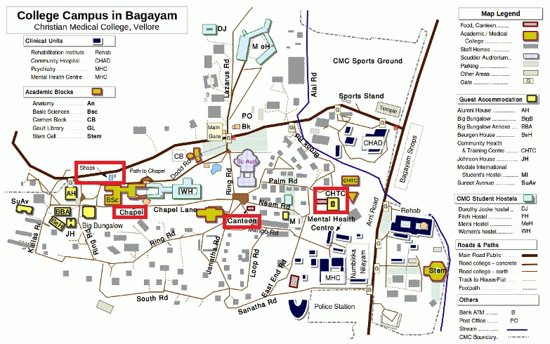

The taxi should take you directly to the CHTC Guesthouse in Bagayam College campus. Note that this is separate (9km away, about 20 minutes by bus) from the Main Hospital area, where you will be doing most of your postings. The places you’ll frequent are:

Hostel

The taxi should bring you directly to CHTC hostel. The rooms are spacious and comfortable, with 3 power sockets (bring adapters) per room.

Make sure you are comfortable living with your roommate because it is generally difficult to get an extra room at the fully-booked hostel, and single-room costs the same as double-room.

Room cleaning is available for free on weekdays if you leave your room key at the staff counter. You may have to specifically request a change of sheets etc.

There are no ironing boards available in the rooms in CHTC. Full laundry+ironing services are available for around 15Rs per piece, and clothes will generally be returned to you 2-3 days after you pass them in (sometimes it takes longer – so bring more sets of clothing especially you will sweat quite a lot). There are also horror stories of clothes getting stained by the laundry service, so use it at your own risk. Alternatively, choose Modale as your accommodation and your laundry is settled too.

Some of us handwashed our clothing. They dry pretty fast because of the low humidity, but do consider buying your own pail from Harris and bringing your own detergent.

Food

The main campus food options are the 1) CHTC hostel canteen and 2) College Canteen.

The hostel canteen is located within CHTC guesthouse block itself. It is cheaper, but it only opens at certain times of the day and the food is less varied.

The college canteen is located 5 minutes away from the hostel, and is open from around 7am till late in the night. Food here is varied and tasty, and prices are affordable. You will probably eat here most days.

Locals take their drinks with a lot of sugar. Requesting your drinks to be made with ‘no sugar’ usually turns out just right for the average Singaporean.

College store

This is located 15 minutes west of the hostel. It stocks most of what you will need, including water, food, toiletries and toilet paper (not provided in CHTC rooms, but provided in Modale).

Note: Water is available in 1-2L bottles, but it is more cheaper and more convenient to get a water dispenser and share it amongst yourselves. You can get a dispenser for around 300Rs and coupons for 20L tanks of water (sold in bunches of 5, 10 or 15). They will send the water tanks to directly outside your room, if you call 4420 at the hostel counter. Delivery usually happens one working day after you make the call.

Chapel

There is evening service on Sunday at 6pm at the main auditorium (marked Sc. Auditorium on the map above). There is also a church choir practice, which starts earlier at 4pm.

You will notice various posters / notifications on boards around the campus for competitions, events etc. These can be a lot of fun and are recommended. In particular, International Students’ Night happens on the first Monday of each month. Additionally, every Wednesday most international students meet and have dinner at Darling Residency at 7pm.

2. Getting internet access

Get a CMC web account for Rs 500 for 1 month, from the CHTC Guesthouse staff. This also provides wifi access in the Main Hospital. In your rooms, there are Ethernet cables provided. Wired connection is faster and more reliable than wireless connection, as it is anywhere else. Everyone will need to get one- it does not seem to be possible to share the connection. With every log-in, only 1 device can access internet. This can be a huge source of annoyance, so do bear with this.

3. Buying a local SIM card

The college store occasionally stocks SIM cards. Ask them to see if there are any in stock. If there aren’t any, you will have to purchase a SIM card outside of campus.

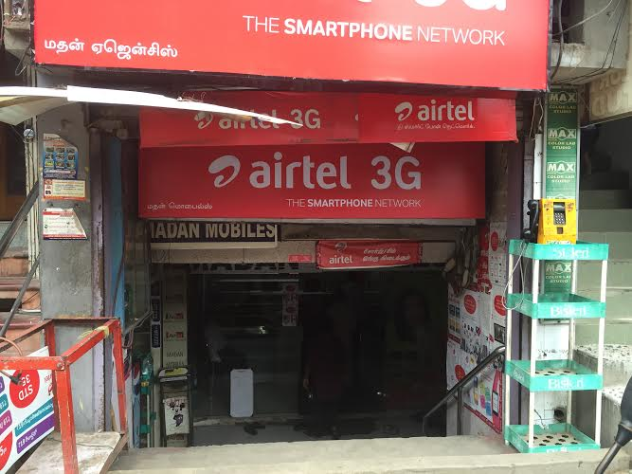

The most convenient location is opposite the Main Hospital. There are a number of shops selling SIM cards outside the hospital, but we found the one in the above photo to be more ‘professional’ and reliable. In other shops, some problems were encountered with activation of SIM cards. To get to the above shop, cross the road from the CMC main gate, turn left, and walk down 2-3 minutes (note: there is a main gate and a side gate – if in doubt, ask the many security guards standing around).

You must bring a passport photocopy, visa photocopy, and a passport photo. Inform the store of the type of SIM card you need (e.g. nano, micro). A 30-day 1GB 3G + 150 rupee TT plan will cost 300 rupees.

For Airtel, after purchasing and inserting the SIM card, wait for 4 hours before dialing 59059. Follow the instructions given by the operator and the card will be activated shortly. Note that you will need something to open your SIM card door- a paperclip or a nametag.

Tip: Whatsapp will prompt you to register your new number. Doing so will mess up your contacts, so just hit ‘no’ and Whatsapp will continue to work as per usual using your old number.

4. Meeting Ms Sheela on your first day

Time and place

You should meet Ms Sheela at Carmen Block, Principal’s Office, Bagayam Campus at 9am. This is near the Main Gate (refer to the map above).

She will settle administrative matters (including Form C, your first posting details, and posting fees). You may also meet the school director who will tell you more about CMC and what to expect.

Do bring: passport photocopy x 2, visa photocopy x 2, passport photo x 2, Rs 8000 per person (1 month)

Thereafter, you can email her what department you want to be posted to on the following week. She is quite flexible when it comes to scheduling, but it is prudent to give her 3-4 days notice.

Bank transfer

You will be prompted to do your bank transfer at the bank opposite the main gate of the CMC College Campus. As it only opens from 1300 to 1900 (and your meeting with Ms Sheela will end around 1030), a good plan may be to travel to the hospital first and get your posting schedule for the week before returning and settling the bank transfer. The process in itself is simple: enter the bank, go into the first opening on your right and then to the last counter. Obtain a queue number and fill up the bank transfer forms which Ms Sheela would have given you. Upon completion of the bank transfer, you should receive a receipt (⅓ of the original form) and that would be all.

5. First day in the hospital

How to get to and from the hospital

Free Shuttle Buses
There are scheduled shuttle buses every morning. The earliest starts at 0645, the next is at 0700, while the last bus for the morning is at 0735. the 0645 and 0700 buses will be near the main gate while the 0735 bus will be near the college canteen. Buses back to hostel will be waiting at Asha Building at various times, including 1330, 1430 and 1630. You can check the bus schedule at “transport department” noticeboards located near the main gate of the Bagayam campus, and Asha building in the hospital.

Public Buses
The public buses 1 and 2 will take you to the hospital. You can catch the buses outside the campus main gate from either side of the road (yes, both buses will lead to the same destination). Frequency is approximately one in 5 minutes or so. If you are unsure where to alight, ask the conductor. Costs 4 rupees/person/trip, paid to the ticketmaster on the bus. A good way to remember when to alight would be to prepare to alight slightly after the Vellore Fort.

To return to hostel from hospital, you can either
- Exit the hospital by the back gate (west side of CMC), turn right, then take bus 2 which stops near the steps to the Clinic
- Exit CMC main gate, cross the road and walk forward and to your right for about 5-10 minutes (southwest) till you reach the main bus station, where you can take bus 1 or 2 back to the hostel.

Auto (taxi)
Can take 2-4 people per vehicle depending on your body habitus. Do settle on price with driver before getting onto the vehicle – if not they will demand more money from you when you alight. For a trip from hostel to hospital, 120 rupees is reasonable but do not pay more (locals rarely pay more than 100). You can request that they drive slowly (and safely).

Orientation to the hospital

To be honest, some of us are still pretty lost around the hospital even after 4 weeks here at CMC. Note that there is a main gate (through which the shuttle bus will enter every morning) and a side gate (from where the buses exit), which both face different roads. The main buildings which need to be noted are:
- Main building -- where most of the wards + OT are at
- ISSCC building -- for paediatrics and OBGYN wards
- A ward -- for food
- Asha building -- where the shuttle bus will be at + where the library is
- Out-Patient Department (OPD) building
- Paul Brand Building -- for the surgical department offices

Should you find yourself lost, do not hesitate to ask any of the security officers for help. They are more than willing to guide you in the right direction.

Getting your schedule

Your first priority should be to find your department and introduce yourself to the secretary. The secretary will give you a timetable to follow. Your days will usually end around 1330 or 1730, depending on if there’s afternoon clinic/teaching. It’s generally free and easy and you will not be sorely missed if you decide to take it easy.

Where to eat

The best places to eat are:
- A ward canteen -- can be very crowded during lunch hour; dosai and omelette bread are exceptionally tasty. Biryani is the most filling meal so do consider it.
- Alpha Clinic -- for a quick snack; the puff pastries are very good and a cold soft drink may hit the spot in the middle of a hot afternoon
- Sree Shanti – on the left side after exiting from the back gate of CMC. Sells “Subway-ish” food with some gloriously smooth Milkshake (ask for less sugar). It is a must to go there for some quick fix for fresh vegetables.
- Ladies’/Males’ intern quarters (LIQ/MIQ) -- cheaper, quieter
- Café at the top of ASHA building
- Sai Suprabatham Veg Restaurant – opposite the back gate of CMC; good Indian food

Most patients will eat at the YWCA canteen block, which is the most affordable. Food portions are large, but it is usually extremely crowded and they do not cater much to foreigners (ie not much English, and no utensils).

6. Going out

Where else to eat

Darling Residences is an excellent place for you to get some much-needed proteins into your system. Recommended dishes are 1) the chicken tikka masala, 2) the honey chicken tikka, 3) mango lassi, 4) palek paneer, 5) garlic naans and many many more! Public buses 1 and 2 go to Darling Residency as well; Darling Residency is about mid-way between hostel and hospital. Bus ride should take about 10 minutes and cost about 4 rupees.

Darling bakery is another place you can venture to for breads, cakes and snacks. Must tries are 1) pani puri 2) chicken lollipop. Take bus 1 or 2 and tell the bus conductor ‘Darling Bakery’. It is between hostel and Darling Residency. There are large signs pointing to it.

Saravanah Bhavan is a vegetarian restaurant which is about 10 minutes walk away from the hospital main gate.

Foodie’s Kitchen is a decent place for Chinese food. Take an auto, reasonable price for the trip should be ~30 rupees.

Hundreds Heritage is a fine dining restaurant. Take bus 1 or 2 and tell the bus conductor ‘Hundreds Heritage’. Bus ride should cost about 6 rupees and take about 40 minutes. They may specially drop you there, seeing we’re foreigners.

Other options:
- Hotel Shawarma: walk from CHTC or order in 99448 28882
- Domino's Pizza: order online or call in
- Hotel Chinatown: walk from CMC, good non-vegetarian food
(Some find the food very starchy though. After 2 weeks of indian food, it passes as chinese food somehow.)
- *Hotel Aavana Inn: walk from CMC, rooftop restaurant called Earth Plate (recommend cheese fondue)
- *Vellore Kitchen: go to the Fine Dining section
- Tom's Diner: western food, quite far away though. (We didn't try but it was recommended by one of the doctors)
- Fry Yo: Fried chicken delivery, tastes a little like kfc, burger not nice but chicken itself is good
* = best food on the list

There are many good places to eat around VIT (Vellore Institute of Technology). It is about 40 min to an hour away but worth the travel. Take the bus to Chitoor bus stand and take an auto to VIT. Good places are China Valley for momos (their version of wanton) and chinese food and Victor’s Diner

Where to buy things

College store should be able to supply most of your basic needs and requirements

There are supermarkets around, Harish and More.

Local clothing can be acquired at:
- Pacchaiyappa Silk (5 min walk from CMC)
- Varus
- Namaste (a big store next to Bagayam swimming pool -- ask around where the swimming pool is)
- Another smaller store next to college store
- Small shops opposite CMC.

Fruits – the best fruits we have found are right outside the CMC side gate. Exit from the side gate, turn left, and look for this air-con fruit store. There are also many roadside vendors who have decent fruits. You might welcome the fibre given the lack of green leafy vegetables in the canteen food.

Some things you can do outside hospital
1. Badminton: courts in CHTC, opposite college canteen. To bring your own rackets and shuttles and nets.
2. Table tennis: table in CHTC, near the gate nearest college stores.
3. Basketball: Court at CHTC
4. Climb college hill: the hill that you'll pass on the way to CMC, pretty much just outside CHTC. Quite fun and quite easy to climb, about 20-30min to the top. Very nice view and can try to watch sunset too.
6. The CHTC room has star movies and HBO.

Cinema theatres – Vishnu cinemas has both English and Tamil movies. Auto ride is about 150 rupees from Bagayam campus. If you want to watch local Tamil movies, there are theatres much nearer e.g. Lakshmi theatres.

C. Learning

1. Choice of departments

Generally, CMC practices quite a high standard of medicine. It does not feel like a developing country hospital where “anything goes”, rather, the investigations and treatment is quite similar to what we will do back home. At each point in time you can choose to be “officially” posted to one clinical department. You will be allowed to follow their rounds, clinics, OTs etc.

The highly recommended departments (read: pro-teaching) are: Rheumatology, Nephrology, Paeds (III), Paeds surgery, Cardiology, Endocrinology, HPB. Your mileage may vary, but it helps to be friendly and actively introduce yourself and ask questions. You will need to take charge of your own learning – do not expect to be spoonfed, they are not responsible for you and to be honest have no incentive to ensure that you learn. But they will not ignore you if you are enthusiastic and ask questions. Below are some special notes on a couple of departments:

Infectious Diseases

The ID department in CMC was recently formed in March 2015. They are NOT an official teaching department in CMC, which is why you won't see any local students with them. Mrs Sheela will not know how to get you there (hopefully this changes for the readers of this guide!).

Instead, go directly to their department office at the ID Training and Research Centre (IDTRC) outside the hospital's Jubilee Gate and meet their secretary. Introduce yourself and explain that you want to do a posting etc. He will call Mrs Sheela and get her to send your posting order email over, then bring you to see the HOD or deputy in the main hospital premises. The department schedule is on one of the notice boards in IDTRC itself.

On the spread of cases there: prepare for an onslaught of TB (including MDR and XDR TB) and HIV, plus a bit more mycology and parasitology than you would find in Singapore. Presentations of infectious disease are mind-blowingly exotic/florid.

Note that most of the TB patients under ID have extrapulmonary infection or are not actively infectious (coughing/sneezing etc), so there is no need to wear an N95 mask all the time. The team does not, so it would be awkward for you to as well. The actively infectious are kept in an isolation ward, but it is not atmospherically sealed --> Things are different from back home; there is no feasible method to protect yourself as well as you’d normally expect.

Do not expect to learn how to deal with run-of-the-mill bacterial infections here. General Medicine in CMC is how general medicine should be; it’s not the dumping ground that exists back home. Their specialists are competent at managing a broad range of patients, including of course complicated cases with multiple conditions; comparatively little gets handed off to the subspecialist departments. Patients receiving what in Singapore would be “ID-only drugs” like amikacin/tigecycline/colistin are handily managed by the general medicine doctors. (Partially also due to the fact that India has a terrifying antibiotic resistance problem caused by indiscriminate use of antibiotics in the community.) ID sees a lot of undifferentiated cases too, so malignancies and rheumatological conditions are constantly on the differential list.

Because of the above, it is recommended that you do at least a 2-week posting in ID in Singapore, IN EITHER TTSH (for HIV medicine) OR SGH (for transplant/onco ID) before coming here. There are a lot of things you won’t be able to appreciate when you have insufficient background knowledge, compounded by the language barrier.

Things you should follow: journal club, grand rounds (Thursday), ward rounds (if there are new patients), "consults" (blue letters), General OPD (Tuesday and Friday). HIV clinic on Wednesdays is +/-.

General Surgery

There are about 7 surgical teams here in CMC. Do not expect to be allowed to do too many procedures – this is a well-developed hospital and not some struggling developing country hospital that is a “cowboy town”. The advice for those wanting to do surgery is to stick with your team for a longer duration of time. Those who switched teams every week and ended up not being able to scrub in much for the operations, whereas those who stuck to a team longer were gradually allowed to do more things. Each team will have its own schedule, so please follow them as best as possible. Outpatient clinics are excellent opportunities to see many florid signs which may not be present in large quantities back home.

We have found the endocrine surgery team the most welcoming to medical students and they are happy to allow medical students to scrub in.

Obstetrics

Labour ward is busy all the time but there will not be many opportunities to deliver babies as priority will go to their medical students/nursing students who have a quota of deliveries to do. They don’t really care about you much, so you have to be on-the-ball constantly to grab every opportunity to observe or help out with something. The labour ward is very different from what you will see in Singapore so this is definitely an eye-opening experience!

Medicine & Paediatrics

There are at least 5 medicine departments and 3 paediatric departments; each has a certain “focus” but to be honest they are more similar than different. The departments function quite like those back home, but the cases are quite a lot more interesting. E.g. in Singapore a paediatric seizure is usually a simple febrile fit – here it’s anything from inborn error of metabolism to meningitis to structural abnormality to syndromic kid. There is a disproportionate amount of complicated cases since CMC is a tertiary referral hospital and a lot of cases that cannot be sorted out elsewhere get referred here. Hence the departments are especially good for seeing undifferentiated complaints and first presentations, instead of constantly dealing with readmissions from ‘frequent fliers’ – hence try to learn the approach to each presentation as you see these cases in the ward.

Community Health Postings
CHADS

CHADS is a peripheral hospital just beside CHTC guesthouse. The main highlight for this would be the home visits or mobile clinics, although CHADS itself is kind of a hospital. Would recommend going for home visits over mobile clinics if you have a choice.

If you're interested in watching/assisting deliveries, possible to ask, probably your best chance here apart from doing O&G posting at CMC (one of us managed to watch delivery).

How it works:
- Vehicles for home visit/mobile clinics leave at about 6.30 from CHADS itself (walk from CHTC)
- Most people were rejected if they didn't go down to pre-register for the trips. Registration opens at 7.30am when you go find the doctors (Dr Jasmine or Dr Rose?), but the bus leaves at 6+, so go down a day before or so to register.

RUHSA (Rural unit for health and social affairs)

It's the more structured among the three programmes, they'll give you a programme for the duration of the posting you chose. RUHSA is similar to CHADS in being a hospital/medical center in itself too, but they take care of a different village that's much further away and they function more like an advanced primary healthcare.

They'll have a programme for you, starting with an explanation of the various programmes and initiatives that they have there, which was quite interesting to learn about followed by a tour around RUHSA. Similarly, there would be mobile clinics, home visits, OPD clinics and delivery room.

How it works:
- Bus to RUHSA stops at the CMC side gate bus stop, leaves at around 7.10am, but try to be there a little earlier just in case because it literally arrives, picks people up and leaves straightaway. You SHOULD confirm with the security guards where is the bus pickup point, because road closures can result in a change in pickup point.
- The bus is labelled/says RUHSA, so you shouldn't miss it.
- The bus ride is 45 minutes
- Bus will return from RUHSA at 4+ to CMC, or alternatively there's a public bus that goes back to CMC too, leaves RUHSA at about 2.15-2.30.

LCECU (Low Cost Effective Care Unit)

It is a hospital run by family medicine department. They have 2 components: 1) Inpatient ~10-20 patients; and 2) outpatient clinics. They are very pro-teaching, but we generally recommend a 1-day posting. You would also see how they function to keep cost as low as possible for the patient.

How it works:
- It's beside Schell Eye Hospital, take the same shuttle bus every morning that goes to CMC via Schell, alight there.
- Remember to pack your own lunch if you plan to stay full day.

2. Seeing cases

It’s recommended to look for and examine cases in free time (e.g. during lunch break or on Saturday) – there are many, many, many good cases and the patients are usually very happy to be examined (much unlike at home). It is good to have a Tamil speaker with you to take history but do note that about 40-50% of the patients are from North India/Bangladesh, so knowing some basic Hindi will help you through physical examinations.

Within each ward, there should be a Patient Audit Book which contains the diagnosis of every patient, and this is updated daily by the nurses. You can refer to this book as a quick guide of potential cases, instead of manually searching through files in every ward.

Maximise your learning from these cases by practicing them as a formal exam case (time yourself, don’t read case notes beforehand etc). Go as a group, practice, and present to each other. You can try to verify your findings with the case notes but unfortunately their documentation is a lot poorer than back home. Do take note that in certain wards, the nurses/departments have become more protective of the patients and do not allow students to examine the patients unless you have received a formal approval from the relevant department secretary.

We found the following locations to be high-yield:

- Cardiology:
  - J ward: Most of the acute coronary syndrome patients are here, but there’s usually still a number of good murmurs.
  - O5 West ward: Ward for pre-op valve surgery. Fantastic murmurs all around – especially diastolic murmurs since rheumatic heart disease is still common here.

- Rheumatology: O5 West ward. Rheumatology inpatients are usually those admitted for complications or for first dose of biologics. Look for scleroderma, SLE and spondyloarthropathy cases – things that we tend not to see in the ward at home.

- Neurology: N1 or N2 ward. Lots of neurology findings including LMN lesions. N2 also has the paediatric neurology cases. Stroke cases are managed by general medicine however, but you will probably have seen your fill at home.

- Respiratory: K ward: Lots of COPD, ILD, pleural effusions and the occasional SVCO.

- Gastroenterology: W ward: Lots of CLD, livers and spleen.

- Paeds: Q5 South, Q6 East, Q5 North: bed allocation is completely random, so only way to find cases is to flip files or follow the ward rounds. Nevertheless there is no short supply of clinical material, from the bread and butter (seizures, bronchitis/asthma, cerebral palsy, nephrotic syndrome, congenital heart disease, biliary atresia, ITP) to the weird and wonderful (SCID, rickets, cystic fibrosis, Cushing’s + peripheral precocious puberty from adrenal tumour, snake bites, minky kinky hair syndrome). Do be careful clerking patients from this ward as the nurse is especially alert for medical students who are not posted here.

- Surgery: You can try O5 East for thyroids and breasts (must check which is their pre-op day and go in the morning of the pre-op day). Outpatient is also a good option.
You are also encouraged to explore the many wards and ask the Staff Nurse in-charge if you are not sure which ‘specialty/department’ is taking care of the patients. For example:

- O3 East – Renal transplants
- O4 West – Neurosurgery
- O5 East – Thyroid, breast
- L Ward – Hematology, Medical oncology
- M2 Ward – Respi
- M3 Ward – Dermatology, CVS
- Medicine wards (E, I) – Variety of medicine cases, ranging from leptospirosis to tuberculous meningitis to haematological malignancies.

3. Clinics worth crashing

Some of us have more departments we want to explore than weeks at CMC. You don’t have to spend a whole week with the department! You may instead opt to attend outpatient clinics for a day or two. The following are especially worth crashing. Try reading up on the physical signs and examination steps beforehand so that you maximise your practice.

- Head and Neck / Endocrine Surgery clinics: One day there and you will have examined enough breasts and thyroids to last you until MBBS. Will get to see all the important kinds of lumps you need to know, from benign (fibroadenoma, diffuse goitre of iodine deficiency) to malignant (all the stages of breast and thyroid CA). There is also a nice mix of first visits and reviews, so can observe all stages of management -- history and examination, core tissue biopsies, completing neoadjuvant therapy and about to go for surgery, post-surgery, undergoing adjuvant therapy, in remission.

- Rheumatology clinic: buffet of all the rheumatology conditions that are our downfall during exams. In one day you can see scleroderma, dermatomyositis, RA, gout, spondyloarthropathies, SLE, JIA, and much more. All with florid physical signs.

- Obstetrics clinic: great for learning about antenatal care and abdominal palpation.

- Leprosy/Hansen’s Disease clinic: Located at CHAD, which literally just next to CHTC Hostel. Clinics are run on Saturday mornings from about 9am to 12pm, in Room 11. This is something you will never get to see during postings back home, but there is a handful of patients happily stable in the community who sometimes get called for exams.

Try to go formally by finding out which is the clinic day (it may change so we are not writing it here) and asking Ms Sheela to post you to the clinic just for a day.

4. CMC Medical Student’s Tutorials

Make friends with the local students! They are open to you crashing their teachings/tutorials, some of which are quite useful.

D. Other places to visit

1. Hope Home

Hope House is a children's home for girls which takes care of children that need care and protection. They currently care for 22 girls which includes children with special needs and they range between 5 months and 17 years of age. A number of abandoned kids from CMC are referred here. They have sufficient funding but would love to have visitors.

Web site: http://www.indiahopehouse.org
Facebook page: http://www.facebook.com/indiahopehouse
Blog: http://www.indiahopehouse.com/blogspot.com
Contact: Director - Ruby Nakka +91 96-29-471920

You may like to inform Ruby in advance that you will be going.

Directions:

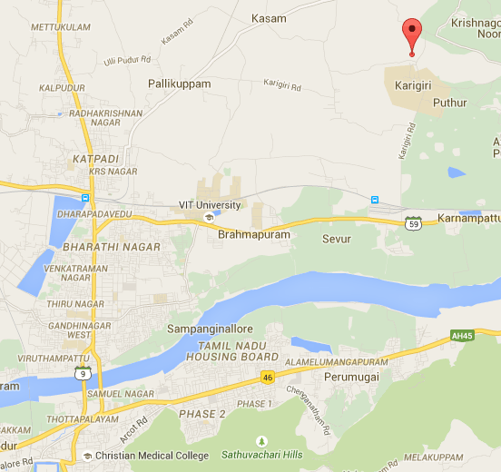
- Take number 1 or 2 bus from Bagayam to Chittoor Bus Stand
- After you get down, take an auto to Karigiri main hospital
- Don't go into the hospital campus but stay on the main road till you cross the Hospital compound wall
- Adjacent to the compound wall, there's a road to the left and when you take a left turn, you'll see only one new building which says "The Hope House" on it.
- If you have any difficulty locating this place, call Ruby
2. Shanthi Gramam Leprosy Colony + Karigiri Hospital

The auto will drop you off at Karigiri hospital. You will start off with a video about the hospital. Then you will visit various departments e.g. physiotherapy, microbiology labs, animal labs (with rats), ophthalmology department, rubber shoe making factory (special shoes for patients with leprosy) etc. This is an eye-opening experience as you will learn a lot about leprosy and you will never see this in Singapore – super interesting.

After Karigiri hospital tour, you can head to Shanti Gramam which is a 5 minute auto ride away from the hospital (ask your auto driver to wait for you). Shanthi Gramam – literally ‘village of peace’ is a haven for aged, destitute persons who once had leprosy. These people continue to suffer due to inadequate attention during the active phase of the disease and are left with permanent deformities. With their visible deformities they are treated with contempt from the general community, even their family members. The home grew out of concern for these old, disfigured, rejected leprosy patient by those who understood their deeper need for love and compassion, apart from physical shelter and care. The inhabitants would love visitors.

Contact: Valsa Augustine +91 9345083541. Aunty Valsa works at Karigiri Hospital. She will introduce Shanthigramam and guide you to visit the place. She loves having visitors and all are welcome to call her.

Direction: Take bus 1, 2 to Chitoor bustand and take an auto to main Karigiri Hospital (100 rupees). It’s less than 5min drive from Karigiri hospital. OR you can contact Ms Sheela to arrange an auto to Karigiri hospital from Bagayam. It will be 700 rupees per auto so share with 3 others!

3. Travelling out of Vellore
- For those who want to escape the heat and look at scenic spots/go trekking:
  - Hillstations such as Yelagiri, Kodaikannal, Ooty are good choices (All in increasing order of distance from Vellore, good to google in advance to plan itinerary)
  - Salem – Yercaud hillstation. Slightly far but offers a very high vantage point. The temperature can drop to close to 15 deg, so do wear something substantial.
- For shopping and international food: Large cities with large malls and more urbanization
  - Bangalore
  - Chennai
- Those interested in looking at heritage sites/massive Indian temples:
  - Kanchipuram
  - Mahabalipuram
- For beautiful beaches and quaint french cafes:
  - Pondicherry

Transport can be arranged for these places via the CMC transport department if you email them (transport@cmcvellore.ac.in). They're quite efficient but it would be prudent to check the price if you don't want to get a shock afterwards. Cost is based on distance, so take note of the starting mileage and ending mileage in your vehicle. Do the math and calculate your cost! There will also be day/night halt charges and you will have to pay for your driver’s meals too. Also good to travel in large groups- to stay safe, stay with a Tamil speaker and cut costs.

E. When you leave

1. Elective evaluation form

Find Miss Sheela in her office on one of the weekdays of your last week in CMC. She will sign your electives form (that you must submit to DO). The process itself is perfunctory.

2. Collect online form C

Do not forget to ask Miss Sheela for your form C when you visit her for your evaluation form. Horror stories have emerged of how some exchange students were stuck at the Indian customs and nearly missed their flights due to the lack of this seemingly-unimportant form.

Written April 2015 by - Nigel Fong, Khoo Bo Yan, Liu Ren Jie, Liu Ren Wei, Marianne Tsang, Vivien Lee, Zhao Yue David, Zhang Wei.

Edited by Janice and friends (Batch of 2018) – August 2016.

Edited by Gabriel Low, Tan Jiekai and M Premikha (Batch of 2019) – August 2017

