ANTICOAGULATION MEQ
Cherie

Mdm Foo is a 77 year old Chinese lady. ADL I Comm ambulant without aid. She has a background of hypertension, hyperlipidemia, DM on diet control, AF, previous rheumatic heart disease with mitral stenosis. She is on Warfarin 2mg OM, simvastatin 20mg ON, nifedipine 30mg OM and bisoprolol 2.5mg OM.
She has been admitted to IM on your call after a fall. She had slipped and fallen in the toilet and landed on her L arm, L leg, and knocked her head lightly against the wall.
She had no chest pain/ SOB/ palpitations, no giddiness, no weakness or numbness before the fall. No LOC as well. Post fall she was able to get up with some help and complained of mild headache and L arm and L leg pain. On systemic review you discover she has been unwell in the past week with low grade fever and cough, and took some medications that her nephew gave her. Rest of systemic review unremarkable
O/E, she is alert and oriented. Otherwise, neuro exam is normal. H S1 S2 MDM. Lungs clear. Abdomen soft non tender. Bruises noted over L arm and L leg and L temporal region
- What are the most pertinent/relevant invx to do? Pick 5
- FBC
- ECG
- 2D Echo
- PTT
- CXR
- MRI brain
- CRP
- PT
- UFEME urine cultures
- skull xray
- CT brain
Ans: A B E H K
CT brain showed acute SDH w no midline shift. Urgent Neurosurgery review overnight was requested. The NES on call reviewed the scan and patient, suggested for conservative management unless GCS drops or clinical deterioration.
INR was 6. Hb 11.0 TW 8 plt 450. ECG showed SR, HR 80, no ST or T changes.
- What is the best management for the supra-therapeutic INR?
- stop warfarin, give IV vit K
- stop warfarin, give cryoprecipitate stat and IV vit K
- stop warfarin, give PCC stat
- stop warfarin and repeat INR cm
- stop warfarin, give PCC stat and IV Vit K
Ans E
If the INR is less than 5.0 and no bleeding is apparent, the next dose of warfarin is withheld and the subsequent maintenance dose is reduced. If the INR is 9.0 or less and the risk of bleeding is low, the next one or two doses of warfarin are withheld and the INR is repeated in 48 hours; in these patients who have no evidence of bleeding, the American College of Chest Physicians (ACCP) recommends against the routine use of vitamin K. If the INR is greater than 9.0, warfarin is withheld and 2.5 to 5 mg of oral vitamin K is administered.
Patients with an elevated INR and serious bleeding (or those requiring rapid anticoagulation reversal) are treated by withholding warfarin and administering 10 mg of vitamin K intravenously. For patients with critical need of anticoagulation reversal (for example, intracerebral bleeding), the ACCP recommends administration of 4-factor prothrombin complex concentrate rather than fresh frozen plasma.
Inactivated 4-factor prothrombin complex concentrate contains factors II, VII, IX, and X and is indicated for the treatment of major warfarin-associated bleeding in conjunction with vitamin K. If unavailable, FFP can be used in its place or a 3-factor prothrombin complex concentrate (missing factor VII) with a supplemental dose of FFP or recombinant activated factor VII

- You ordered the PCC, but 15min later the nurse calls you to say the blood bank has no stock of PCC tonight. What do you do?
- Give cryoprecipitate instead
- Give FFP 500ml instead
- Give IV Vit K instead
- Give FFP 15ml/kg instead
- Give recombinant factors
Ans D
You stopped the warfarin, gave the patient 15ml/kg of FFP, and IV Vit K. Repeat INR came down later. After several days of inpatient stay, NES suggested to repeat CT scan which showed reducing size of the SDH. They decided to allow the patient to go home with a TCU with them, CT scan before TCU, and to KIV restart warfarin if SDH resolving.
Many years later, this same patient is scheduled to go for elective cholecystectomy for symptomatic gallstone disease.
- What is the best management for her peri-op management of warfarin?
- Continue warfarin through surgery
- Stop warfarin 5 days before surgery
- Stop warfarin 3 days before surgery
- Stop warfarin 5 days before surgery and bridge with clexane
- Stop warfarin 5 days before surgery ad bridge w dabigatran

Ans D
The most appropriate perioperative strategy is to stop warfarin 5 days before the procedure and forego bridging anticoagulation. This patient is scheduled for an invasive procedure with a high risk of bleeding and therefore requires discontinuation of warfarin for surgery. Stopping warfarin 5 days before surgery usually achieves the standard target of an INR of less than 1.5. HOWEVER, MUST DECIDE IF PT IS AT HIGH RISK OF THROMBOEMBOLISM- IF SO, WILL NEED BRIDGING.
In perioperative patients who require interruption of chronic anticoagulation, the need for bridging anticoagulation must be determined, typically with the use of the CHADS₂score + indication for anticoagulation in the first place eg Bridging typically done if high risk patient eg prosthetic valve/ high chadsvas score like this patient with RHD and chadsvasc 5

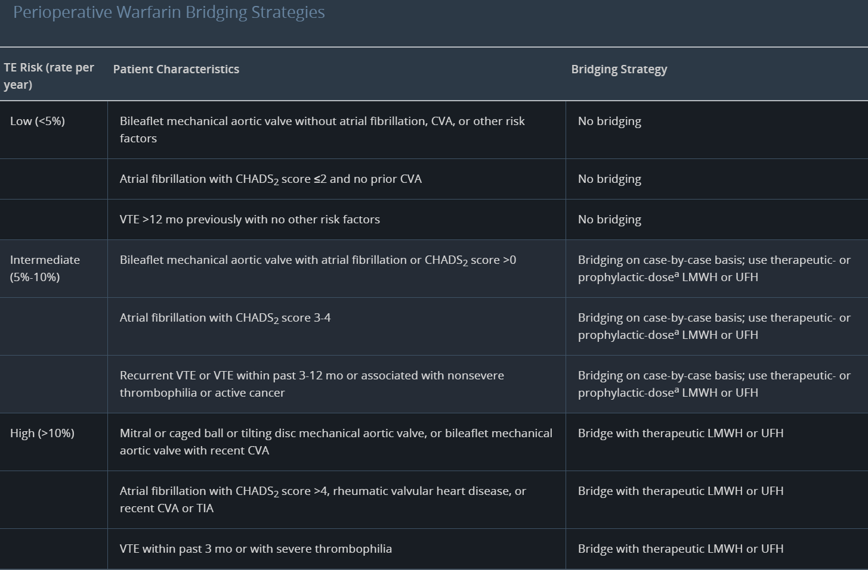
- Adapted from Douketis JD, Spyropoulos AC, Spencer FA, et al. Perioperative management of antithrombotic therapy: Antithrombotic Therapy and Prevention of Thrombosis, 9th ed: American College of Chest Physicians Evidence-Based Clinical Practice Guidelines. Chest. 2012;141(2 suppl):e326S-e350S. PMID: 22315266

After the surgery, the surgeon calls you to ask when and how they can restart the warfarin.
- How should we restart warfarin?
- Give PO warfarin 5mg x 3 days and check INR daily
- Give Clexane and start warfarin after 3-5 days of clexane
- Start Heparin and warfarin together, then take off heparin when INR >2 for >24h
- Start clexane and warfarin together, take off clexane after 5 days and INR >2 for 24h
- Start Heparin and warfarin together, then take off heparin when INR >2 for 3-5 days

Ans D
Heparin should be given for no less than 5 days and only discontinued at that time if the INR is therapeutic for 24 hours. Warfarin may be initiated on the first or second day of heparin therapy. Because factor II and X levels require at least 5 days to decline sufficiently, parenteral anticoagulation should overlap with warfarin for at least 5 days and until an INR of 2 or more is achieved.

- When initiating warfarin, need to overlap with heparin for about five days and until INR is therapeutic (≥2) for at least 24h, before stopping heparin
- Reason is because Warfarin inhibits Protein C and S also, which have short half-lives, and these are anticoagulant factors. If you do not do heparin bridging, then there is a risk of paradoxical thromboembolism when initiating warfarin
- Protein C and S have a short half life while FX has a half-life of 5 days
- Therefore 5 days overlap with heparin is required for FX levels to decrease sufficiently and have a true antithrombotic effect
- Hence to start LMWH and warfarin together and to overlap for at least 5 days or when INR >2 for at least 24 hours (whichever is the longer)

- Patient was frustrated about the hassle of warfarin and all the trouble it caused her. She asks for an alternative drug suitable for anticoagulation for her, but also with reversal agent that she can use. What only other drug fits her request?
- Apixaban
- Rivoroxaban
- Dabigatran
- Clexane
- Heparin
Ans E
Dabigatran has a reversal agent which is Idaricizumab BUT RMB THE HISTORY- SHE HAS VALVULAR AF. NO EVIDENCE FOR NOACS. The only alternative that can be used in her is heparin vs clexane. However in terms of reversal agent, clexane no good reversal agent (can give protamine sulfate but reversal effect is incomplete). Only alternative is heparin which is likely to be rejected by patient as it is an IV medication. no choice but to stick w warfarin

